Hjjh

1. **HTML Basics Tags**

**CODING**

<!DOCTYPE html>

<html lang="en">

<head>

<meta charset="UTF-8">

<meta http-equiv="X-UA-Compatible" content="IE=edge">

<meta name="viewport" content="width=device-width, initial-scale=1.0">

<title>CPU</title>

<link rel="stylesheet" href="style.css" />

</head>

<body>

<h1>

CPU

</h1>

<h2>

<u>

<i>

<b>CPU</b> stands for Central Processing Unit.

</i>

</u> <br>

It is the process of a <u>computer</u> system that carries <br>

out the instructions of a <u>computer</u> program. <br>

It carries out each instruction of the program in sequence, <br>

to perform the basic arithmetical, logical, and input/output operations of the system.

</h2>

</body>

</html>

**OUTPUT**

**CPU**

**CPU** stands for *Central Processing Unit.*  
It is the portion of a computer system that carries out the instruction of a computer program.  
It carries out each instruction of the program in sequence, to perform the basic arithmetical, logical, and input/output operations of the system

**2.Contents and links**

**CODING**

<!DOCTYPE html>

<html lang="en">

<head>

<meta charset="UTF-8">

<meta http-equiv="X-UA-Compatible" content="IE=edge">

<meta name="viewport" content="width=device-width, initial-scale=1.0">

<title>Image</title>

<link rel="stylesheet" href="style.css" />

</head>

<body>

<h1>

Albert Einstein

</h1>

<p>He was a German-born theoretical physicist, widely acknowledged to be one of the greatest and most influential physicists of all time. Einstein is best known for developing the theory of relativity, but he also made important contributions to the development of the theory of quantum mechanics.</p>

<img src="https://s3.amazonaws.com/exams-media-content/ba1768e5-6d4b-4615-9364-15e23980c951/questions/3758825807-1" alt="Einstein" >

</body>

</html>

**OUTPUT**

**Albert Einstein**

He was a German-born theoretical physicist, widely acknowledged to be one of the greatest and most influential physicists of all time. Einstein is best known for developing the theory of relativity, but he also made important contributions to the development of the theory of quantum mechanics



**3. Lists and tables**

**CODING**

<!DOCTYPE html>

<html>

    <head>

        <title>Table</title>

    </head>

    <body>

        <table>

            <tr>

                <th>First</th>

                <th>Second</th>

                <th>Third</th>

                <th>Fourth</th>

                <th>Fith</th>

            </tr>

            <tr>

                <td>1</td>

                <td>2</td>

                <td>3</td>

                <td>4</td>

                <td>5</td>

            </tr>

            <tr>

                <td>6</td>

                <td>7</td>

                <td>8</td>

                <td>9</td>

                <td>10</td>

            </tr>

            <tr>

                <td>11</td>

                <td>12</td>

                <td>13</td>

                <td>14</td>

                <td>15</td>

            </tr>

            <tr>

                <td>16</td>

                <td>17</td>

                <td>18</td>

                <td>19</td>

                <td>20</td>

            </tr>

        </table>

    </body>

</html>

**OUTPUT:**

| **First** | **Second** | **Third** | **Fourth** | **Fith** |
| --- | --- | --- | --- | --- |
| 1 | 2 | 3 | 4 | 5 |
| 6 | 7 | 8 | 9 | 10 |
| 11 | 12 | 13 | 14 | 15 |
| 16 | 17 | 18 | 19 | 20 |

**3.b. Check box**

<!DOCTYPE html>d>

<title>Forms</title>

</head>

<body>

<h2>Choose vehicles</h2>

<form>

<input type="checkbox" id="bike" name="bike"> I have a bike<br>

<input type="checkbox" id="car" name="car"> I have a car<br>

<input type="checkbox" id="boat" name="boat"> I have a boat<br><br>

<input type="submit" value="Submit">

</form>

</body>

</html>

**OUTPUT**

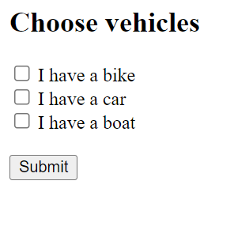

**4. Registration form**

**CODING**

<!DOCTYPE html>

<html>

<head>

<title>Forms</title>

</head>

<body>

<h2>HTML Forms</h2>

<form>

<label>First name:</label><br>

<input type="text" value="John"><br>

<label>Last name:</label><br>

<input type="text" value="Doe"><br><br>

<input type="submit" vale="Submit">

</form>

</body>

</html>

**OUTPUT**

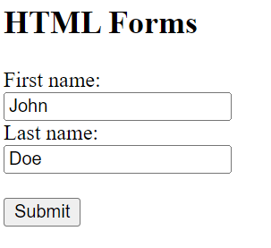

**5. HTML form and validation using HTML5 features**

**CODING**

<!DOCTYPE html>

<html>

<head>

<title>Link</title>

</head>

<body>

<ul>

<li><a href="#birds">Birds Section</a></li>

<li><a href="#ducks">Ducks Section</a></li>

</ul>

<br>

<br>

<br>

<br>

<br>

<br>

<br>

<br>

<br>

<br>

<br>

<br>

<br>

<br>

<br>

<p id="birds">This is the article about birds</p>

<br>

<br>

<br>

<br>

<br>

<br>

<br>

<br>

<br>

<br>

<br>

<br>

<br>

<br>

<br>

<p id="ducks">This is the article about ducks</p>

</body>

</html>

**OUTPUT**

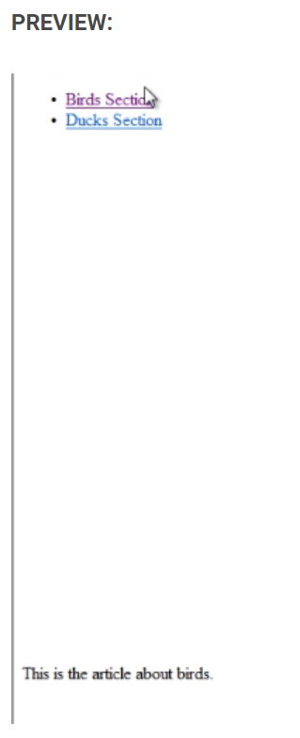

**6. Designing a html page using html and css , friends book**

**CODING**

<!DOCTYPE html>

<html lang="en">

<head>

<meta charset="UTF-8">

<meta name="viewport" content="width=device-width, initial-scale=1.0">

<title>Friends Book</title>

<link rel="stylesheet" href="style.css">

</head>

<body>

<div class="page">

<div class="card">

<img src="" alt="img" srcset="" id="backgroundImage">

<h1 id="TitleName">FRIENDS BOOK</h1>

<form>

<div class="name">

<label for="name" id="yourName">Your Name: </label>

<input type="text" name="" id="textBox">

</div>

<h4 id="field1">1. A message for me!</h4>

<input type="text" name="" id="textBox1">

<h4>2. A nick name for me!</h4>

<input type="text" name="" id="textBox2">

<h4>3. Have you ever lied to me? </h4>

<span>

<input type="radio" name="yes" id="yes">

<label for="yes">Yes</label>

<input type="radio" name="maybe" id="yesMayBe">

<label for="maybe">Maybe</label>

</span>

<h4>4. How do you feel when you talk to me?? </h4>

<span>

<input type="radio" name="happy" id="happy">

<label for="happy">Happy</label>

<input type="radio" name="irritated" id="irritated">

<label for="irritated">Irritated</label>

</span>

<h4>5. Do you like to go on a roadtrip with me? </h4>

<span>

<input type="radio" name="yes" id="ryes">

<label for="yes">Yes</label>

<input type="radio" name="no" id="rno">

<label for="no">No</label>

</span>

<h4>6. Best colour that suits me? </h4>

<span>

<input type="checkbox" name="red" id="bestColour">

<label for="red">Red</label>

<input type="checkbox" name="black" id="black">

<label for="black">Black</label>

<input type="checkbox" name="white" id="white">

<label for="white">White</label>

<input type="checkbox" name="blue" id="blue">

<label for="blue">Blue</label>

<input type="checkbox" name="green" id="green">

<label for="green">Green</label>

</span>

<h4>7. The best moment in out Friendship?</h4>

<input type="text" name="" id="moment">

</form>

</div>

</div>

</body>

</html>

Style.css:

* {

padding: 0px;

margin: 0px;

color:#fff;

}

.page {

height: 100vh;

width: 100vw;

background-color: rgb(0, 106, 9);

display: flex;

align-items: center;

justify-content: center;

}

.card{

height: 95vh;

width: 80vw;

background-color: rgba(11, 186, 255, 0.125);

border-radius:15px;

display: flex;

justify-content: center;

align-items: center;

gap:1rem;

flex-direction:column

}

img{

display: none;

}

form{

display: flex;

flex-direction: column;

justify-content: center;

align-items: center;

gap: 1rem;

}

#textBox{

color:#000

}

#textBox1,#textBox2,#moment{

height: 6rem;

width: 14rem;

border: none;

background-color: rgba(0, 255, 255, 0.393);

}

input {

outline: none;

}

**OUTPUT**

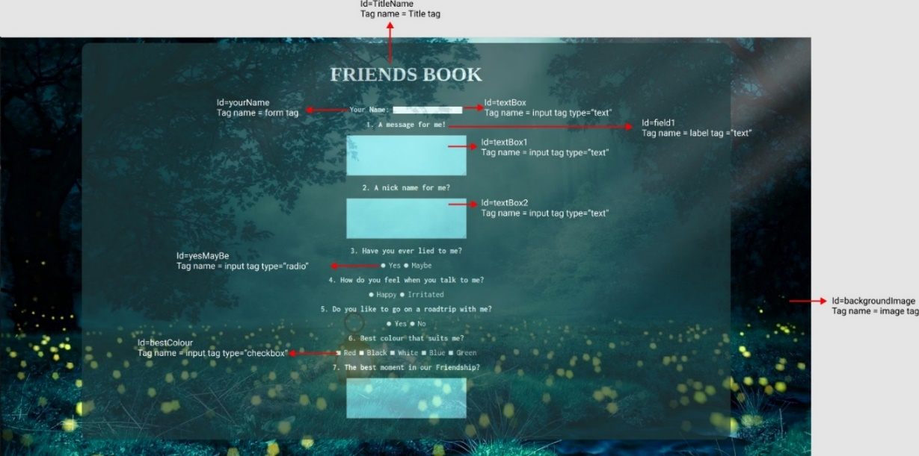

**7. To Apply style specification in HTML page**

**CODING**

HTML Code:

<!DOCTYPE html>

<html>

<head>

<title>Document</title>

<link rel="stylesheet" href="./veg.css">

</head>

<body>

<h1 id="titleName">VEGETABLE SALAD</h1>

<img src="C:\Users\OneDrive\Pictures\Saved Pictures\veg salad.jpg" id="vegetableSaladImage">

<h2 id="benefits">Benefits of Vegetable Salad</h2>

<p id="benefitsParagraph">Aside from their natural good taste and great crunchy texture alongside wonderful colors and fragrances, eating a large serving of fresh, raw vegetables each day can have significant health benefits</p>

<h2 id="steps">Steps to make Vegetable Salad</h2>

<ul id="stepForVegetableSalad">

<li>Take a large and clear glass bowl</li>

<li>Try adding blanched, lightly steamed or roasted veggies like broccoli, french beans, corn, cauliflower, baby corn.</li>

<li>Add lentils, beans or chickpeas or bean sprouts for more protein.</li>

<li>Add marinated veggies like artichoke hearts for tang, or other veggies like radish for some pungency.</li>

<li>Swap in your own favorite combination of dried fruits, nuts and seeds.</li>

<li>Use fresh coriander or chives instead of parsley.</li>

<hr>

</ul>

<footer id="footerText">This easy vegetable salad is packed with a variety of summer produce with all the textures and colors one could ever want</footer>

</body>

</html>

CSS Code:

*{

background-color: darkseagreen;

}

#titleName{

font-family:unset;

color:indigo;

}

**OUTPUT**

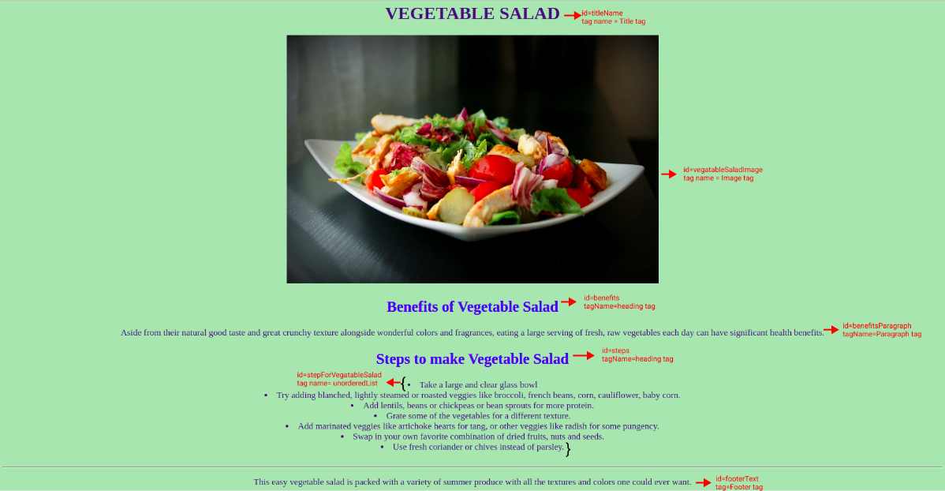

**8. A. Program to check whether a no is even or odd with javascript**

**CODING**

//check if the number is even

if(number % 2 == 0) {

console.log("The number is even.");

}

// if the number is odd

else {

console.log("The number is odd.");

}

**OUTPUT**

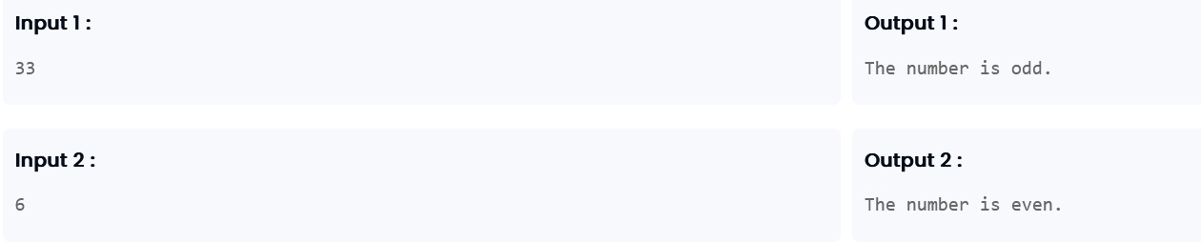

**8. B. Program to check whether a no is armstrong number or not using html and javascript**

**CODING**

<!DOCTYPE html>

<html>

<head>

<title>Armstrong Number Checker</title>

<script>

function checkArmstrong() {

var number = parseInt(document.getElementById("number").value);

var originalNumber = number;

var result = 0;

var digits = number.toString().length;

while (originalNumber > 0) {

var remainder = originalNumber % 10;

result += Math.pow(remainder, digits);

originalNumber = Math.floor(originalNumber / 10);

}

if (result === number) {

document.getElementById("output").innerHTML = number + " is an Armstrong number.";

} else {

document.getElementById("output").innerHTML = number + " is not an Armstrong number.";

}

}

</script>

</head>

<body>

<h2>Armstrong Number Checker</h2>

<label for="number">Enter a number:</label>

<input type="number" id="number">

<button onclick="checkArmstrong()">Check</button>

<p id="output"></p>

</body>

</html>

**OUTPUT:**

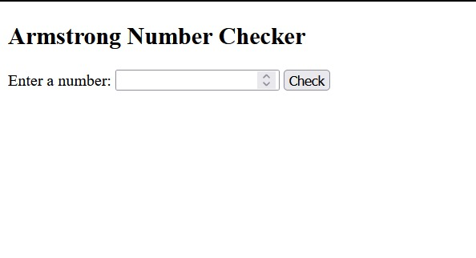

**8. C. Grading program using javascrip (if&else condition)**

**CODING**

function calculateGrade(marks) {

if (marks > 100) {

return "Invalid Input";

} else if (marks >= 90) {

return "A";

} else if (marks >= 80) {

return "B";

} else if (marks >= 70) {

return "C";

} else if (marks >= 60) {

return "D";

} else if (marks >= 50) {

return "E";

} else {

return "F";

}

}

var marks = parseInt(prompt("Enter the marks:"));

var grade = calculateGrade(marks);

console.log("Grade: " + grade);

**OUTPUT:**

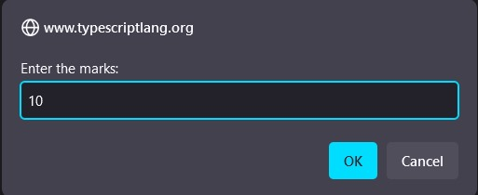

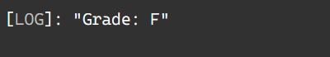

**8d. Program to find the position of substring in the main string using bash (*bash-program):**

**Coding**

read a

read b

c=$(a%%$b*)

d=${#c}

if[$d –eq ${#a}]

then

echo 0

else

echo $((d+1))

fi

#echo “${d}”

**OUTPUT:**

 